President Report 2017
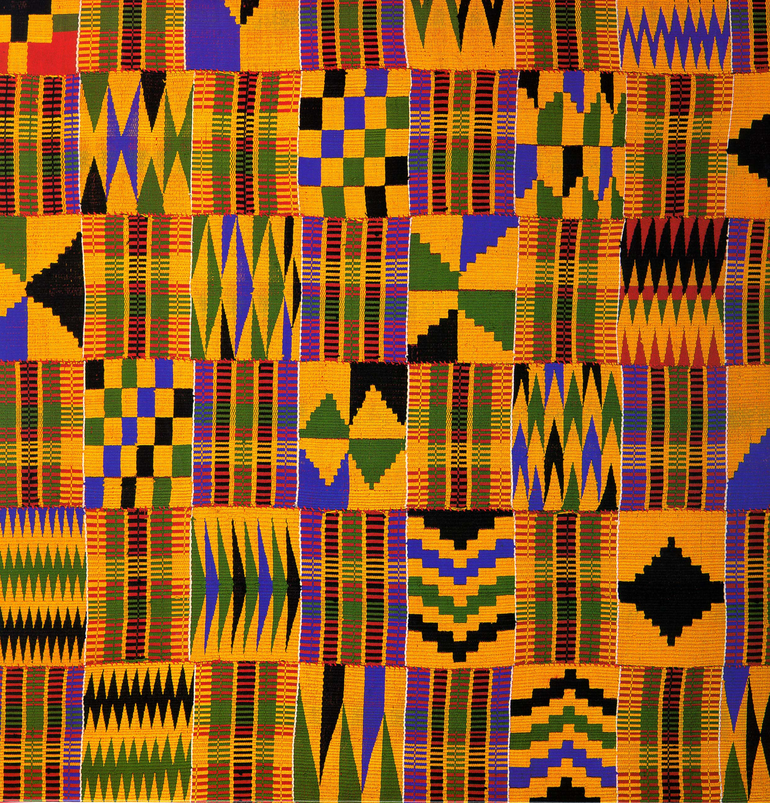

The mission of this Association shall be to preserve the oral tradition of African and African American Diaspora folklore, history, culture, and heritage. Oral tradition is defined as verbally teaching, informing, and entertaining.

March 2017
Black History / Women's Month kicked off our 2017 Storytelling Concert Season with, "The Widows Project". A look into the lives of Coretta King, Meryle Evers and Betty Shabazz as they tell their story how it was to be in their shoes as they stood behind their husband's work.
Attended : 90 Guest

June 2017
The 2017 Spring Concert took us back to the beginning with, "The Evolution of African Storytelling". There were four awesome tellers who guided us through the history of storytelling.
Attended: 70

This year DABS was unable to schedule a Juneteenth Concert due to the many phone calls received to come and perform.
Locations: 15

September 2017
DABS performed again for Grandparent's Day as AARP's main attraction. Stories were told by our DABS Grandparent's.

The "Sky's The Limit Youth Concert". Over the past 5 years we have seen steady growth with the DABS youth along with concert attendance. The youth had a blast as they created the platform for the evening encouraging audience participation. The association is looking forward to next year as encouraging more youth to participate.
Attended: 85

November 2017
Our Fall Storytelling Concert Season closed 2017 with an awesome "From the Land of Dreams to the World of Reality". This concert was about turning your Dreams into Reality. What a great concert which featured four brand new DABS storytellers on a very stormy night.
Attended: 40

DABS kicked off year 3 of our Adopt -a- School Season with Noble Middle School.

December 2017
DABS will be performing in a few Kwanzaa Celebrations within the Detroit Museum District

DABS will be bringing back the association year end Celebration as we reflect and celebrate on 2017 year.

2018
DABS has our 2018 schedule almost complete and it is shaping up to be an eventful year.

